DISD

XX/05/2021

I, Raphael Son Hing hereby declare that I did not plagiarize any content in this assignment and that this my own work.  
Signed:_______________

WEB DEVELOPMENT Task 1

Raphael Son Hing 15004658

Contents

1 Question 1 2

1.1 Introduction 2

1.2 Hierarchical Model 2

1.3 Network Model 3

1.4 Entity-relationship Model 4

1.5 Relational Model 4

1.6 Object-oriented database model 5

1.7 Object-relational model 5

2 Question 2 7

3 Question 3 8

4 Question 4 14

5 Question 5 15

6 Question 6 16

7 Question 7 17

8 Question 8 18

9 References 19

# Introduction

Salutations, in this, I have been presented with the task of making a series of webpages with various features, this include serval tables and collaboration with the XAMPP application to store and retrieve data.

This goal is of yet to make a finished product, various options that are there to help for debugging are left intact and function for easier navigation throughout the sight.



In the finished version, I will of course be limiting the options on this bar depending on status of the user (such as logged in or not) and which page they are on.

Also of note are these…



These appear in the footer of the page, they do not possess any intricate purpose and are merely there for sake of appearance, since the task given do not require one to expand beyond the specified site.

# Login and Register page

The login and register functions are separated into two pages, as I found it impractical for it to work on a single webpage.

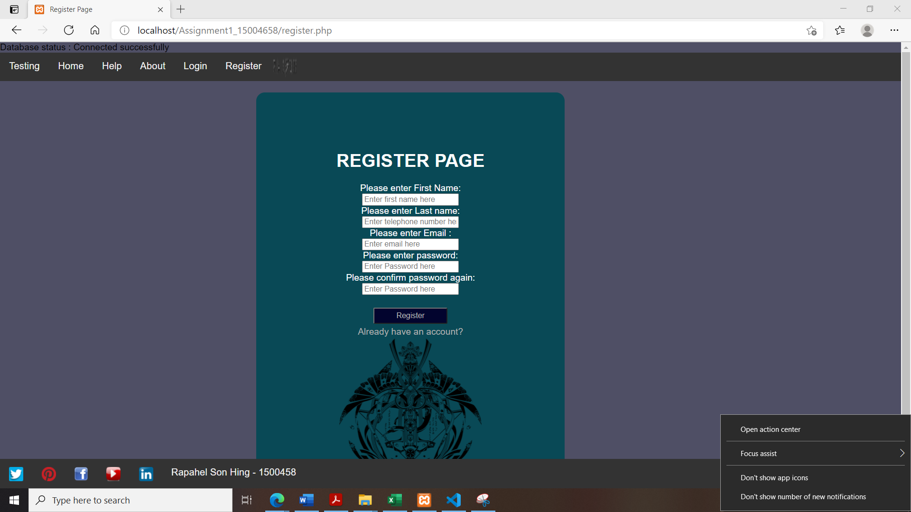

This page works along with PhP admin, it’s works as one predicts, and references the specified lines in the POE.

The password feature needs for an identical data to be entered twice as a way to prevent a common fault.

Inspiration come from the various registration. (Unknown, Registration Forms, 2021)

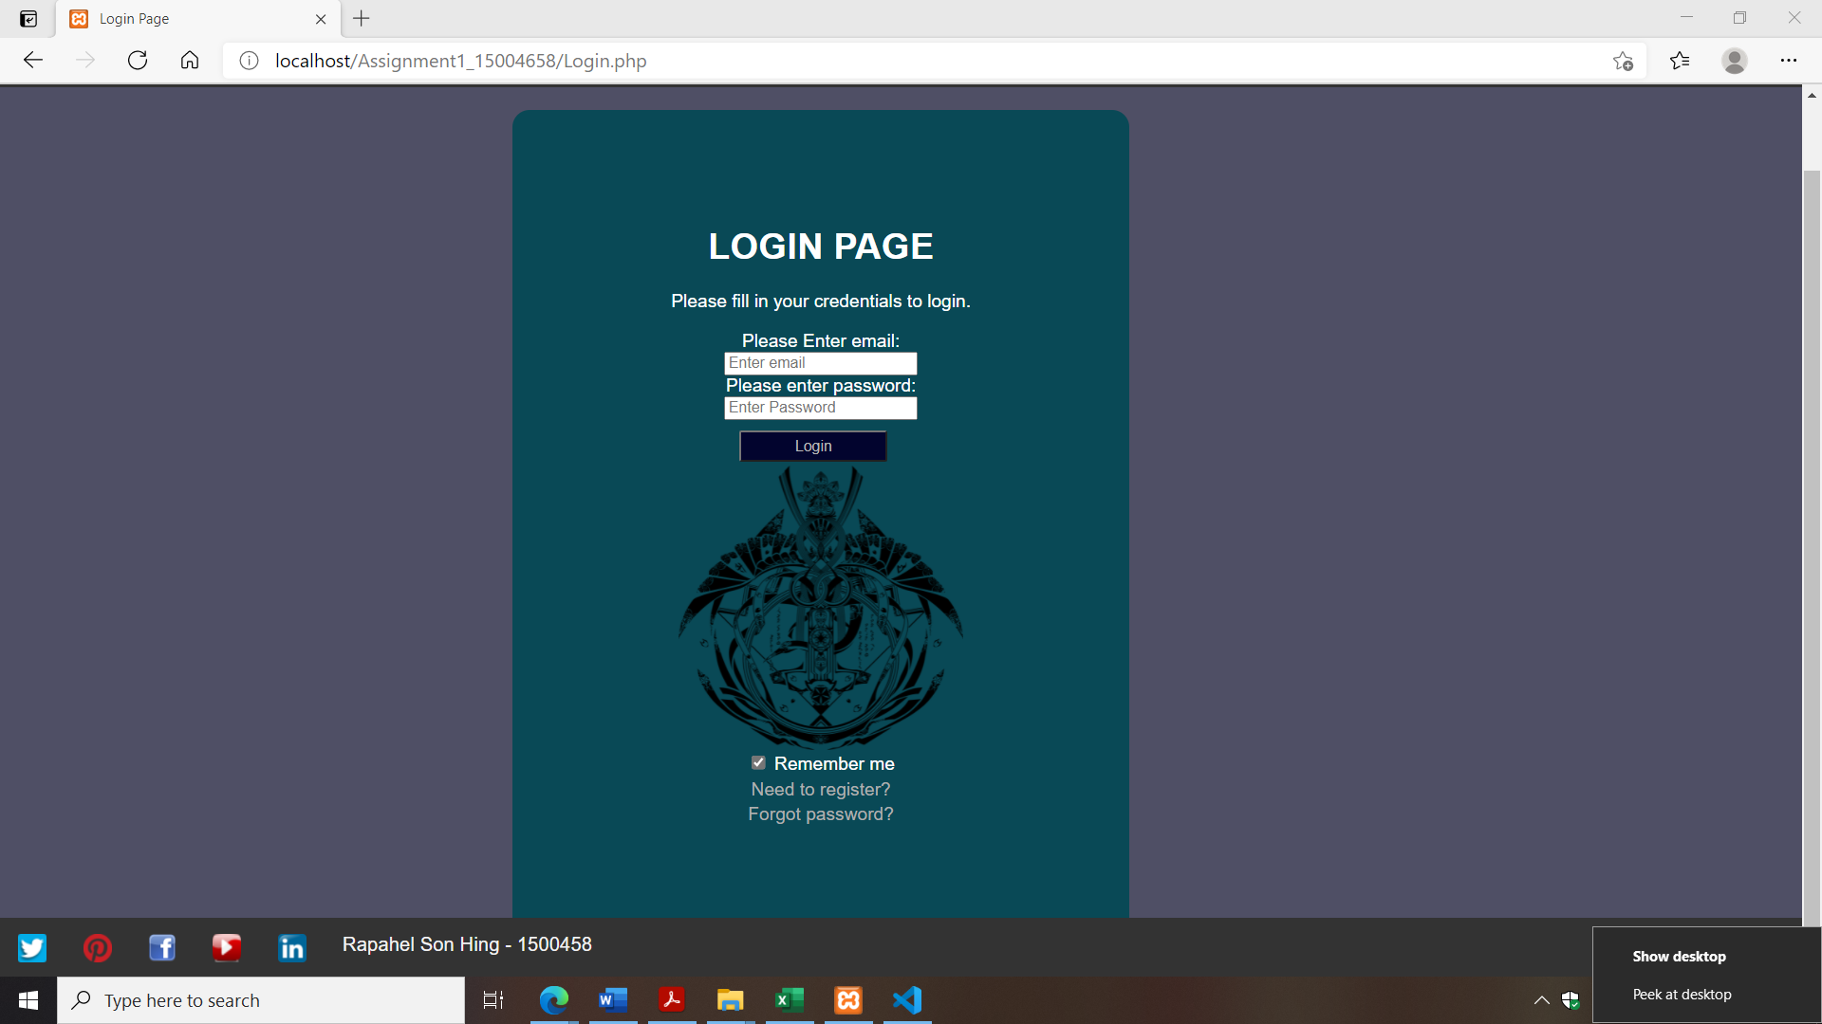

The login function just requires one’s email and password.

Adding the need for other various information is just tedious and unneeded.

Ones one fulfils the requirements the other information is retried and stored within the session function.

The form is inspired by VC very own Login page.

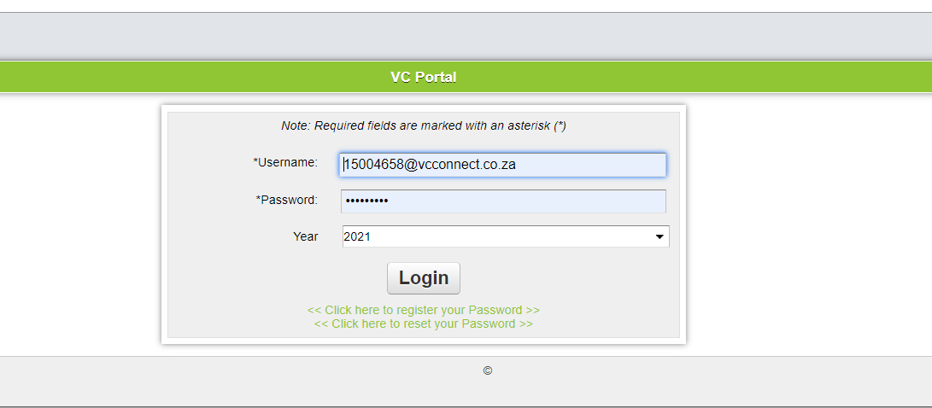

Though the premise of ID number confused me whether you wanted the user to put in their own ID number or have one assigned to them. In my case I opted to do the latter since it would be the one that takes more effort on my part.

# Welcome

This is the welcome page. Please excuse the errors as I’m navigates with the debug tools for this presentation and not currently “logged in” as it were.

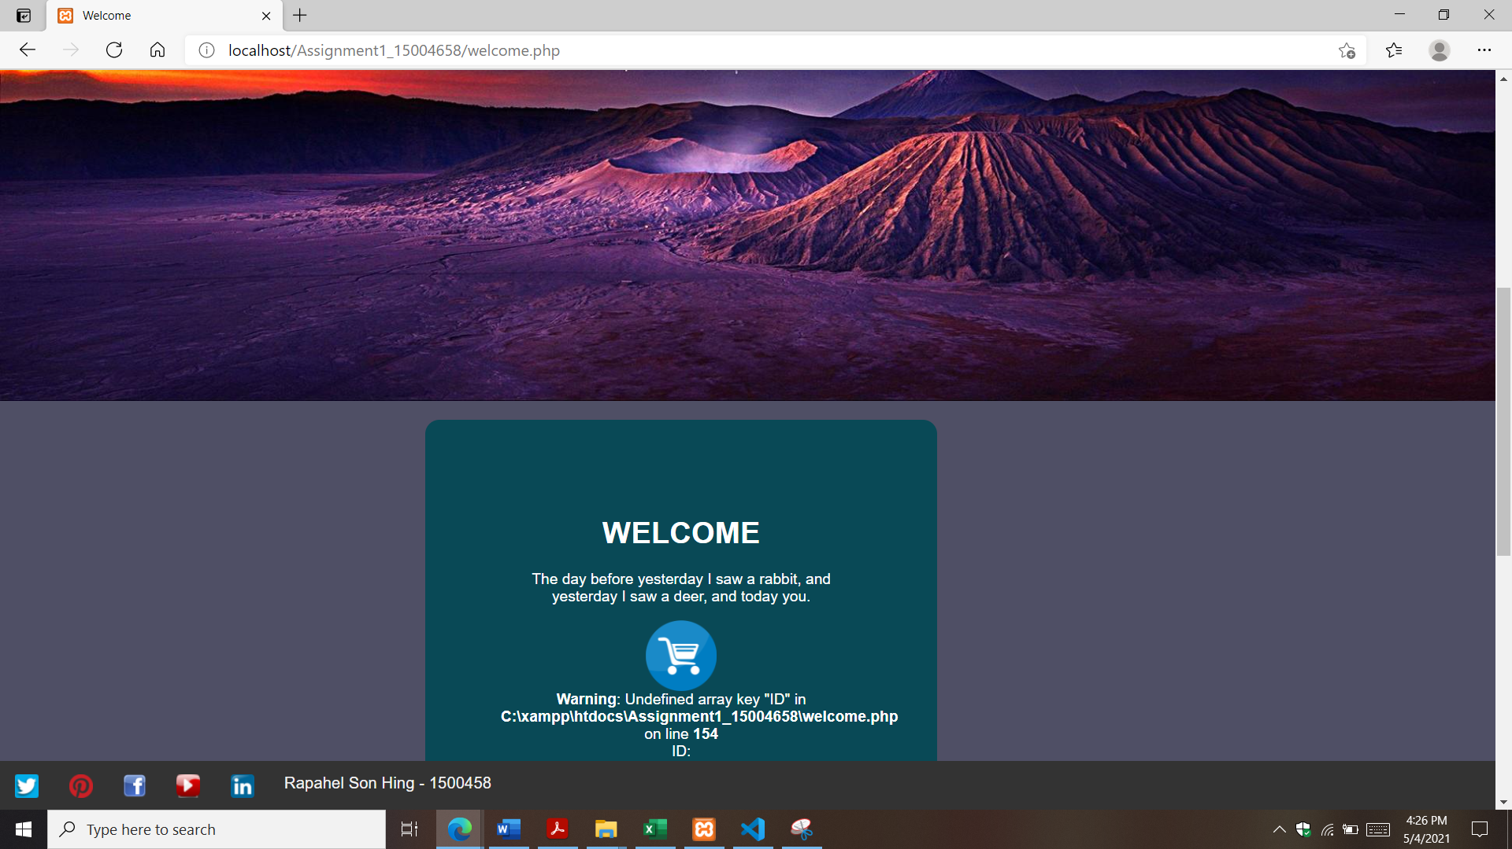

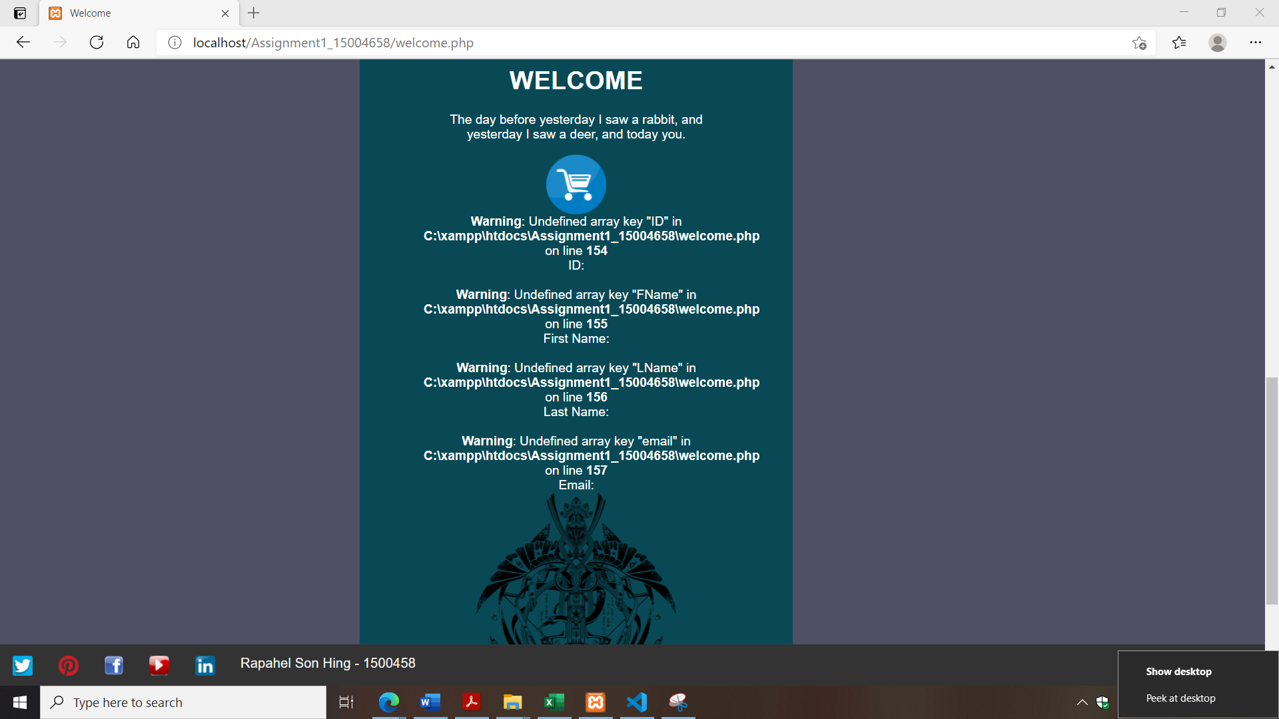

As specified the login page has a link to the products page, in this case the small cart icon functions as a link to the products page.

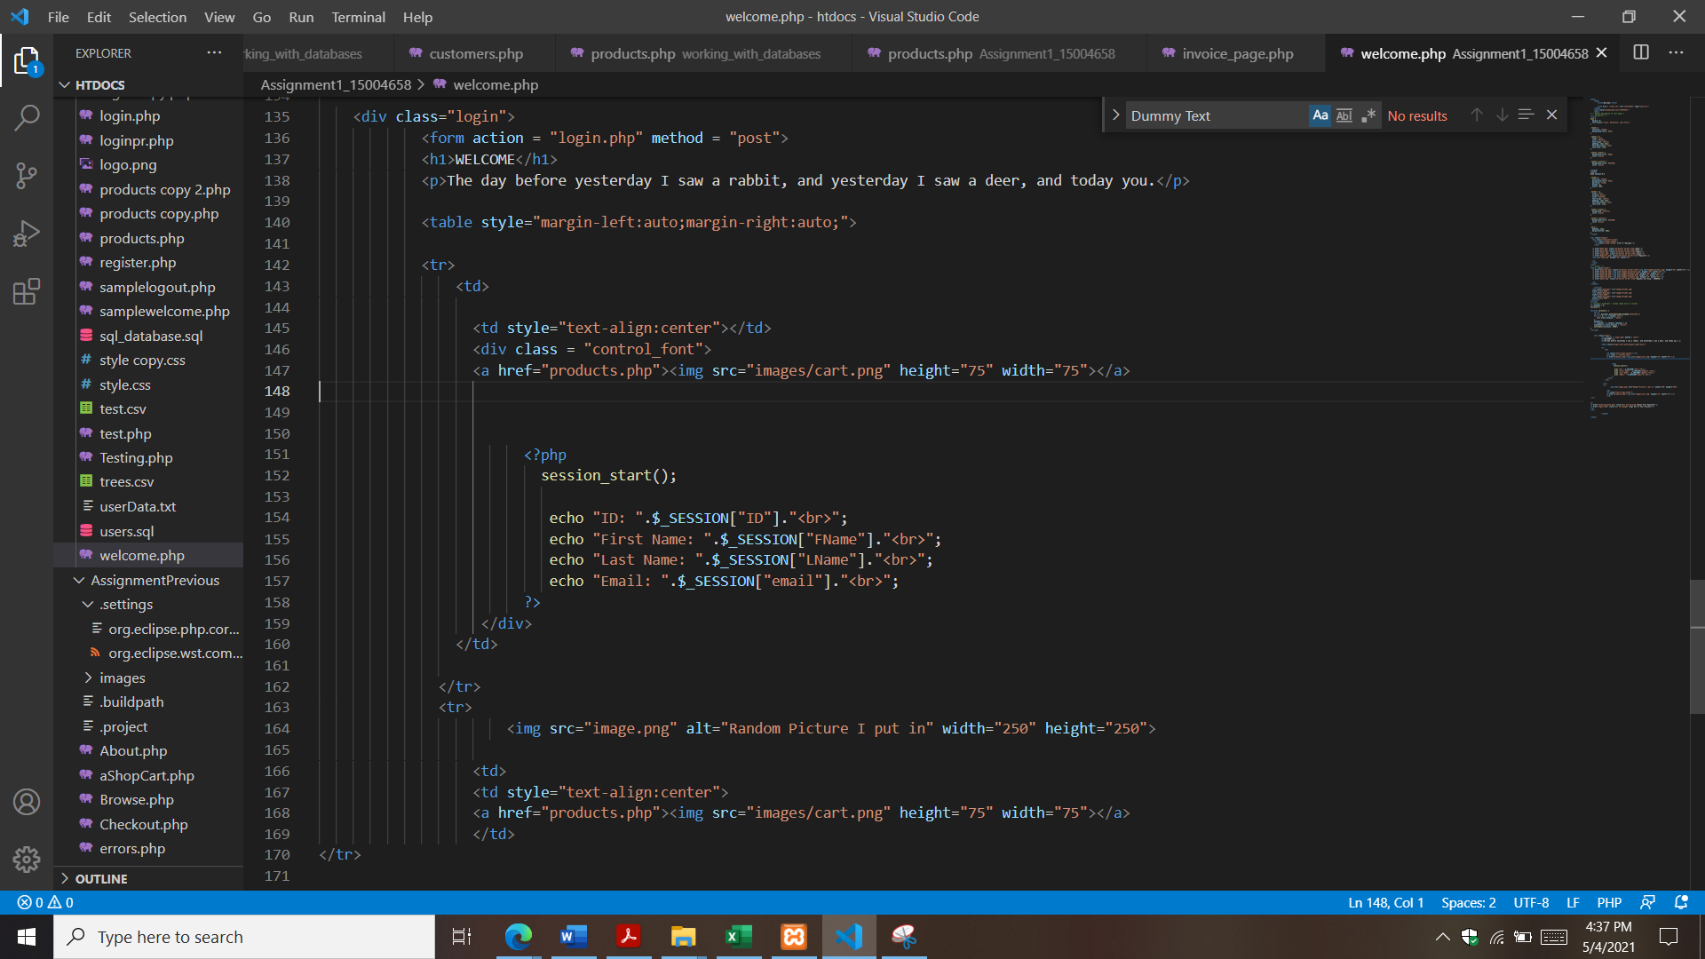

# Products

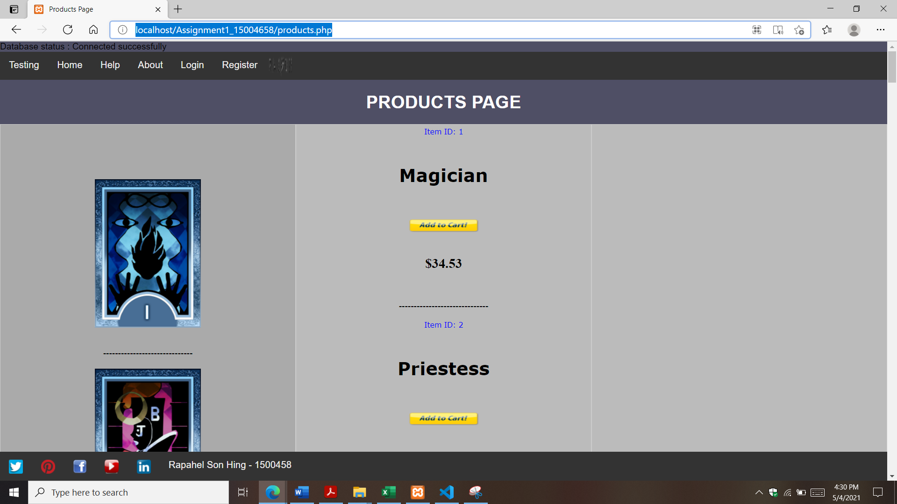

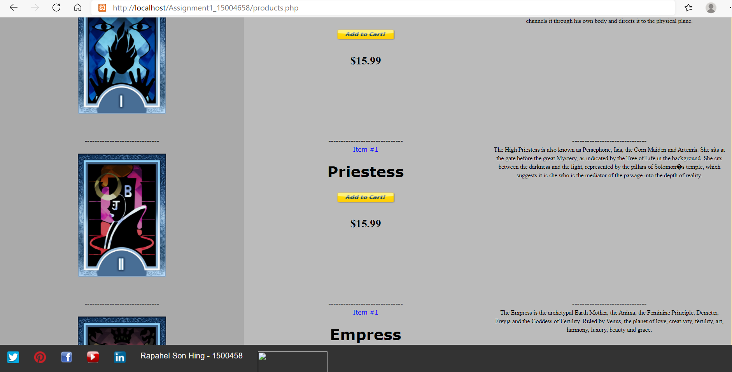

The products are stored in table format, and the information is pulled form a table called tbl_Products.

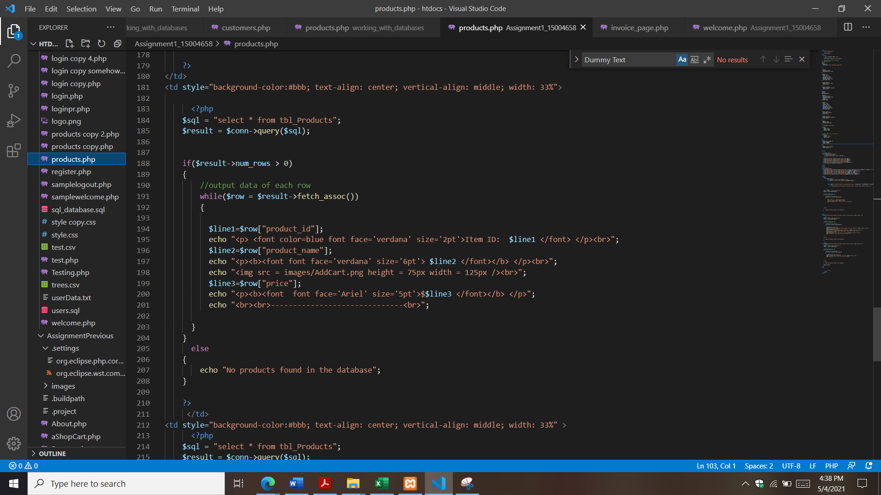

Though the pictres themselves are stored inside the “images” folder, the table itself store the address of the pictures and are needed to reference them.

# General

The colour scheme I have chosen, includes variants of dark cool colours, in a hope to make an appeal of mystery surrounding it.

I choose colours that hopefully contract when reading text, making it easier to read.

Various pictures of a logo appear throughout the sire. I included them as a homage to how sites are overly blatant with their own representation.

That said the logo is just a temporarily fit, as I currently do not have access to a photoshop program, this logo will fill in as a temporary fill measure.

There are links to other pages, however they of yet do not serve much purpose and are there for appearance only. Upon clicking them, most of them will lead to a dead end page, these links will lead to more different pages in the future.

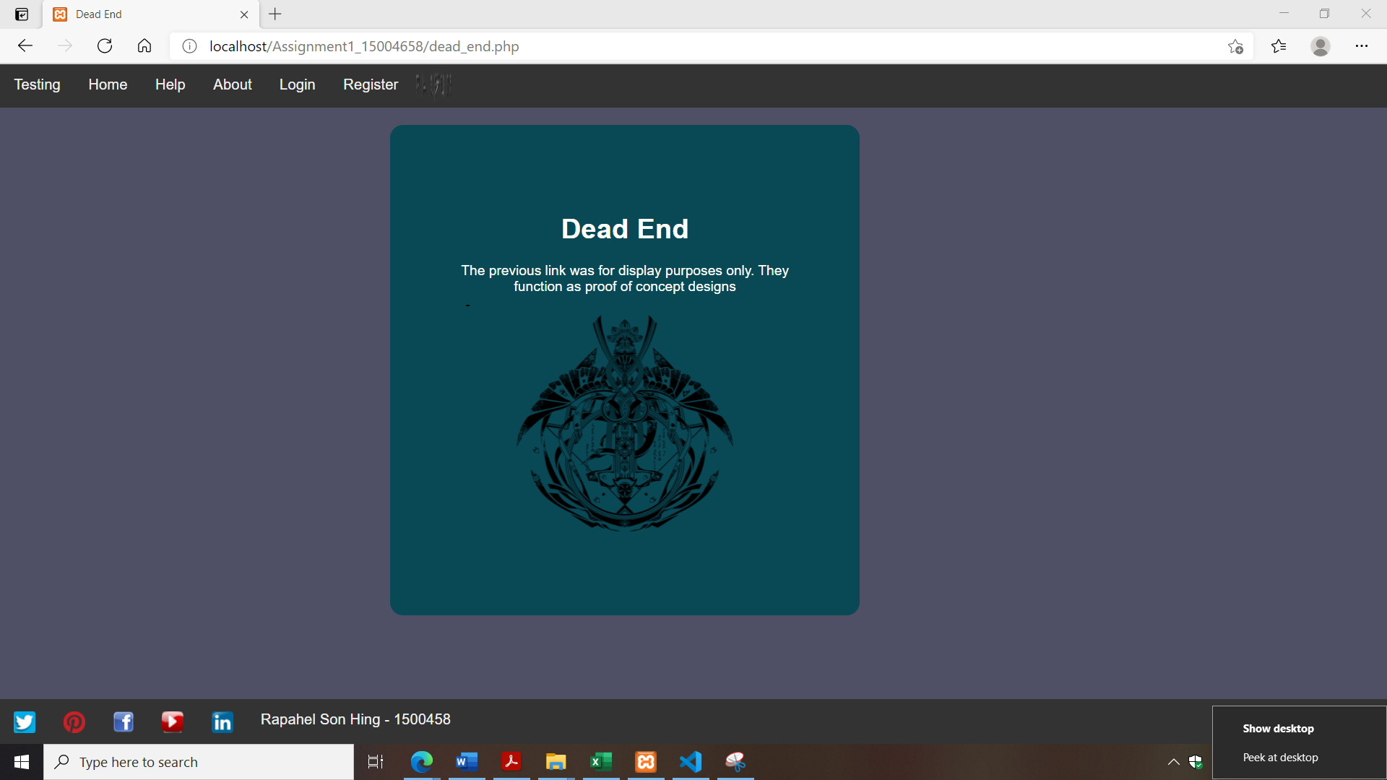

There is also the “Testing” page. I am using it to try different functions and features experimentally. It has no function directly relating to the website as a whole, but I use it as a base to try some things as a trial basis.

# Various Screenshots

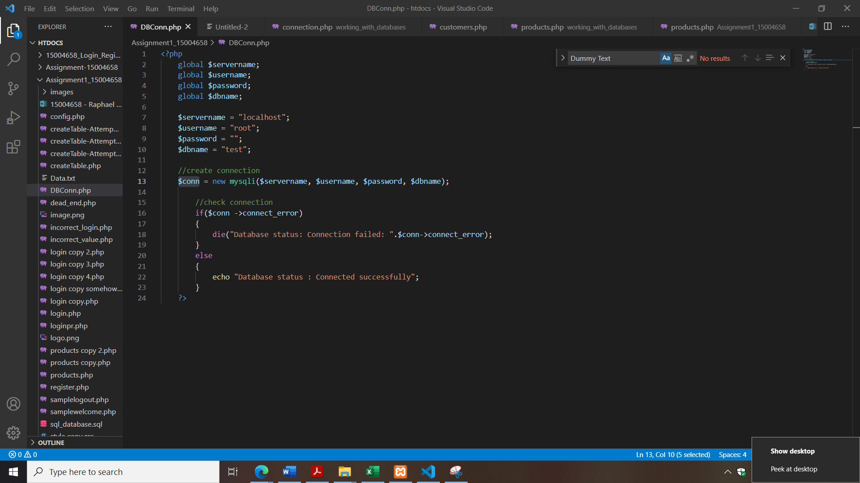 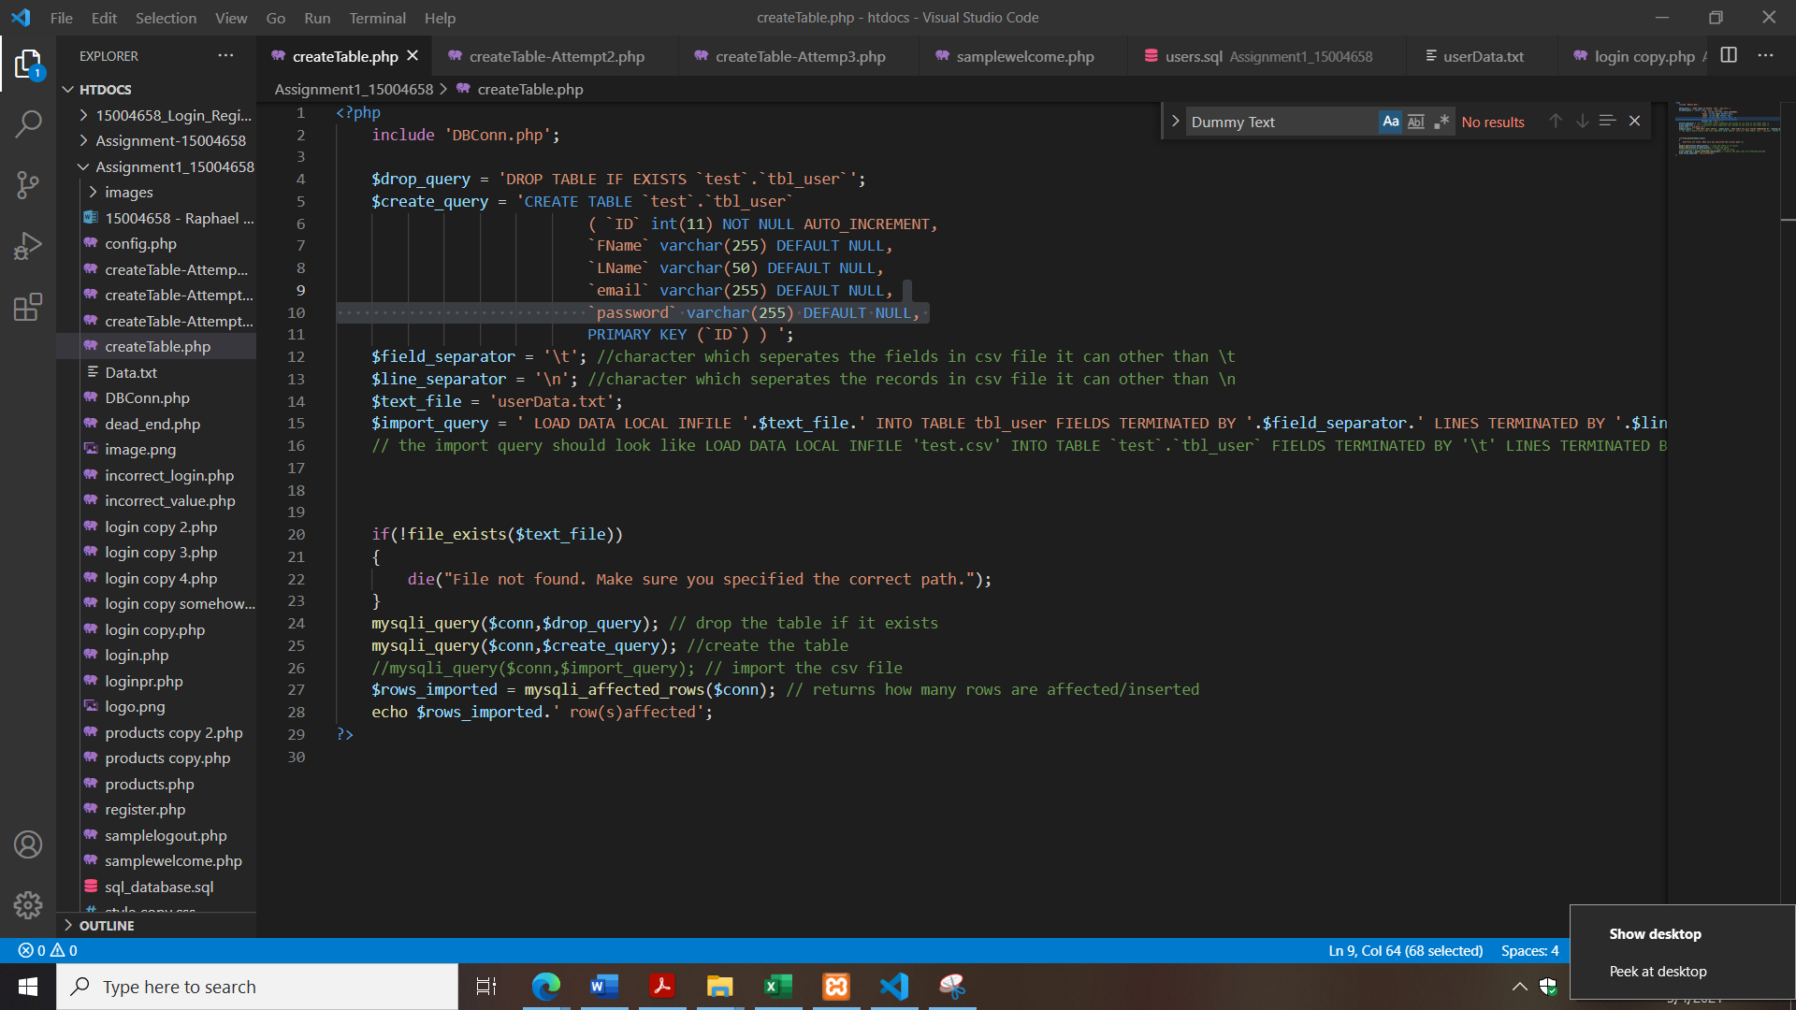 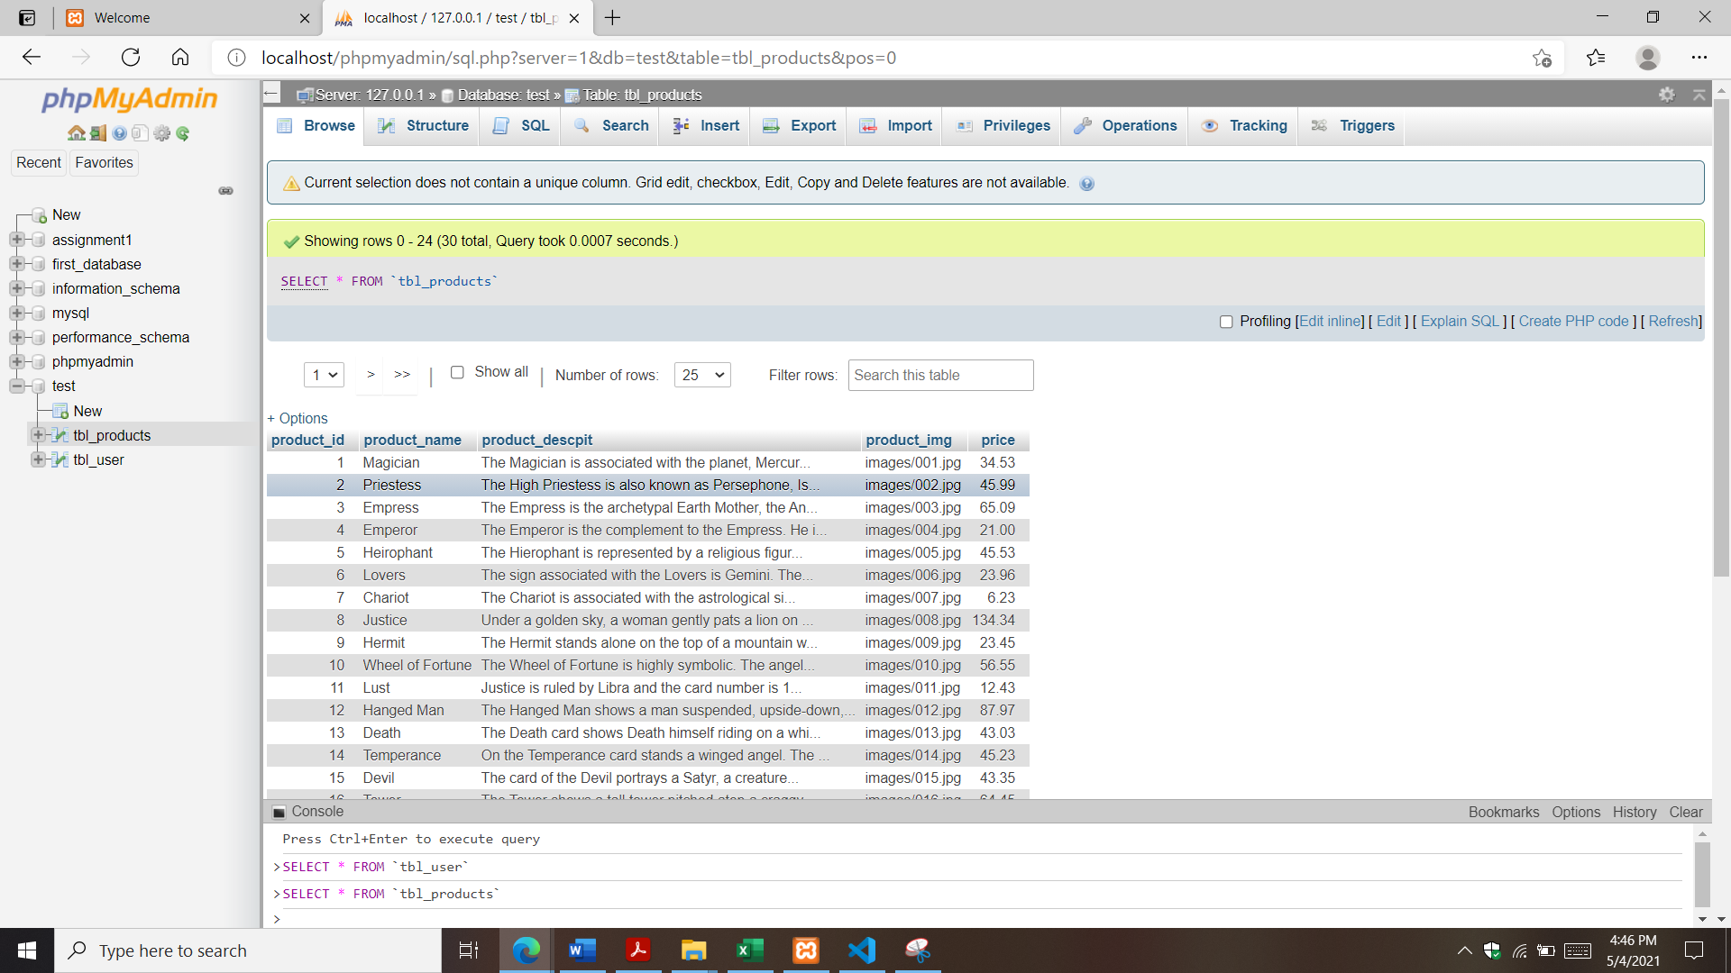 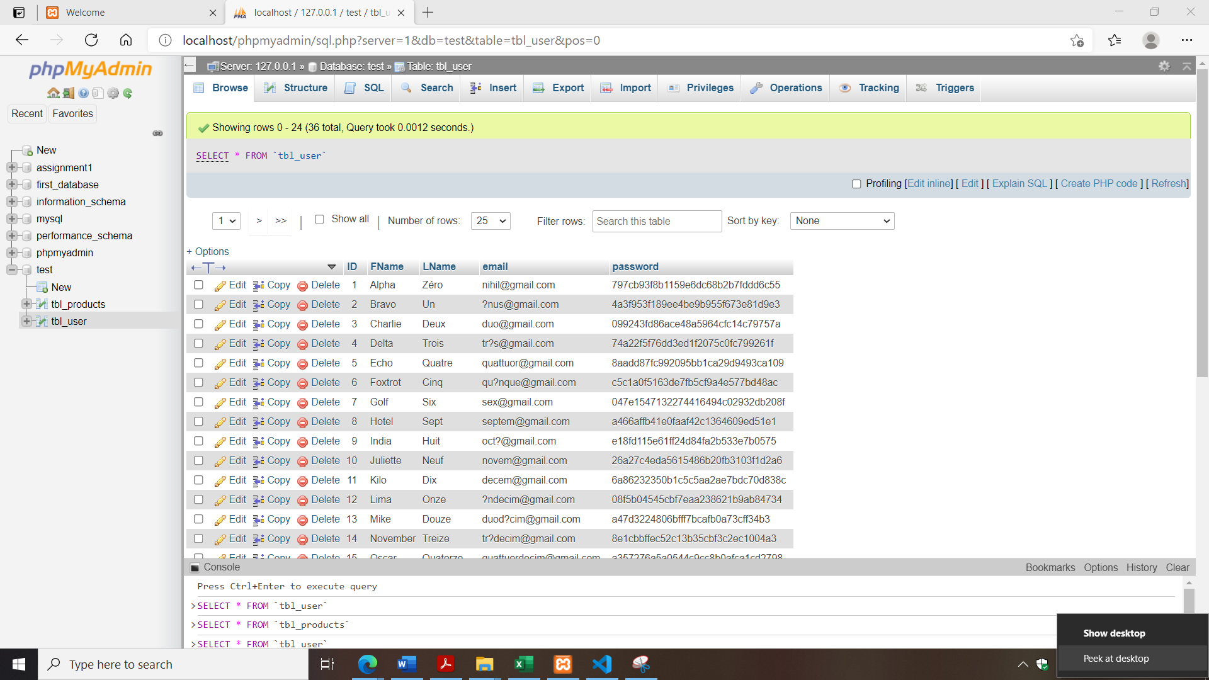 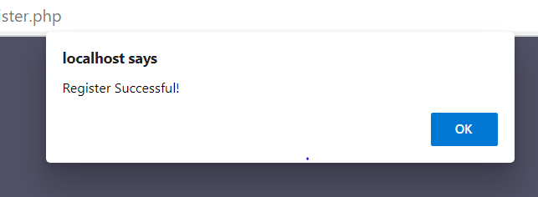

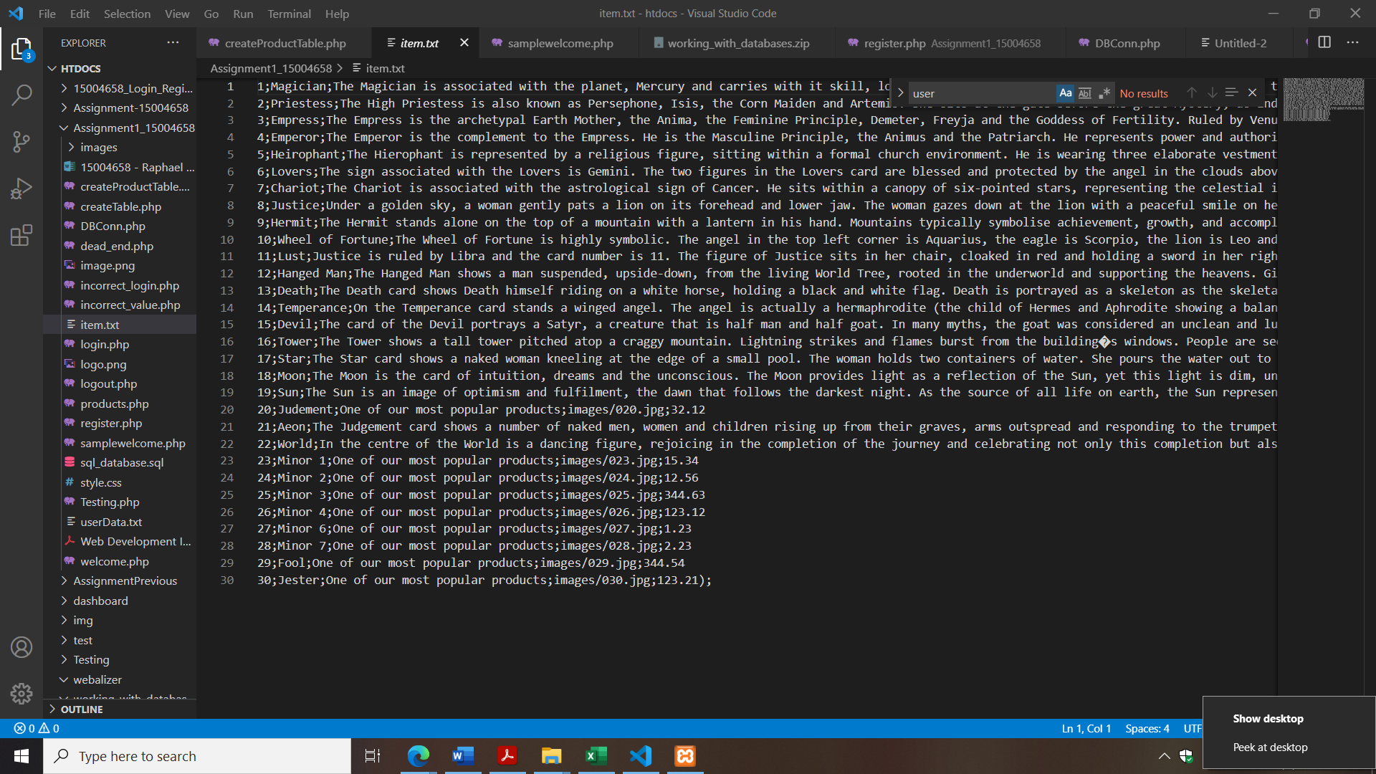 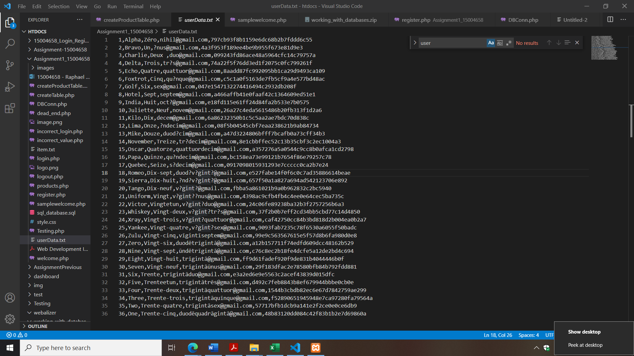

# References

Unknown. (2018, May 18). *DBMS Database Models*. Retrieved from studytonight.com: https://www.studytonight.com/dbms/database-model.php

Unknown. (2018, May 18). *What are Databases? - Examples & Types*. Retrieved from study.com: https://study.com/academy/lesson/what-are-databases-examples-types-quiz.html

Unknown. (2018, May 18). *What is a Database Model* . Retrieved from lucidchart.com: https://www.lucidchart.com/pages/database-diagram/database-models

Unknown. (2021, May 1). *Registration Forms*. Retrieved from Jotform: https://www.jotform.com/form-templates/category/registration

Zameer, A. (2007, December 13). *PHP read text file and insert into MySQL database*. Retrieved from Web Develoment Blog 24: https://www.wdb24.com/php-read-text-file-and-insert-into-mysql-database/#google_vignette